**Remote Sensing Analysis of the Grand-Pierre Mangrove Forest, Artibonite, Haiti.**

Alexandre Erich Georges

Ph.D. Student

University of California, Berkeley

**Abstract.** The Grand-Pierre Bay, south of Gonaives, Haiti hosts the largest mangrove coverage of the country. It is also unique in the Caribbean region because it is the largest river-fed mangrove forest in the Caribbean islands. As such, it is host to extensive biodiversity and is an important socio-economic resource for the Artibonite region in Haiti. However, it has been a victim of anthropogenic pressure, threatening the biodiversity of the forest and its health and extent. This remote sensing analysis will look at how the density and health of the forest have been evolving for the past decade.

**1. Introduction**

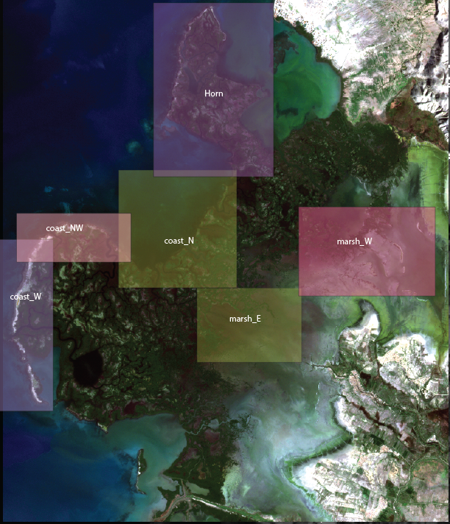

The Grand-Pierre Bay Mangrove Forest is situated at the estuary of the l’Estere, Artibonite, and La Quinte rivers. It is the largest mangrove cover in Haiti and features a sea -> mangrove -> marsh -> land system.

**2. Datasets**

This work makes the use of two datasets for the remote sensing analysis:

**2.1 Landsat**

Landsat 7 and 8 were used to track NDVI changes between the past decade in the region (2010 – 2022). While the resolutions of Landsat 7-8 instruments are lower than other commercially available satellites, it is very convenient for getting numerous readings for long periods of time for a large region. As such, it was mainly used to form time-series of NDVI in the whole forest and certain key regions.

**2.2 PlanetLabs**

PlanetLabs data present much higher resolution (3-5m) but fewer bands for analysis. It is also costly to pull near-weekly data from PlanetLabs. As such, observations around the first 2 months of the year, every 3 years, are taken between 2010 and 2022. This data has been used to monitor mangrove cover and coastline change.

**2.3 Ongoing Conservation Efforts**

**3. Methods**

**Low Tide Data Acquisition**

The partially submerged nature of mangrove forests can lead to inconsistencies when trying to track their cover using remote sensing, as submerged regions during flood tides can get hidden away from the satellite view depending on the time of observation. As such, it was decided to only get PlanetLabs observations at the lowest tides of the year to observe the maximum cover of the mangrove forests.

To get the tidal schedule at our site, we established a 1:1 relationship between it and the tidal schedule at Port-au-Prince, Haiti, located in the same basin of the La Gonave Gulf. This is accomplished via hydrodynamic modeling in Delft3D-Flow, where measurements of the tidal regime in Port-au-Prince are related to the boundary conditions of the basin by regression. ** Make workflow plot explaining this process better **.

With the tidal regime at our site in hand, we can then select available satellite imagery at the lowest available tidal ranges every year.

**NDWI Masking Pre-processing**

To simplify the clustering process of, we mask out the open water regions surrounding the mangrove forest. This is done using the green and NIR bands of PlanetLabs, following the relation defined by **McFeeters (1996).**

**K-means Clustering**

**Deep Learning ??**

**4. Results and Discussion**

**4.1 NDVI Analysis**

**4.1.1 Timeseries Analysis**

Timeseries of the mean and maximum NDVI in the 3 Bays Marine Protected Area have been taken. Areas of interest were the mangrove forest, the Gulf of Gonave coast of the forest, and the “brackish Grand Pierre” lake coast.

**4.1.2 dNDVI Analysis**

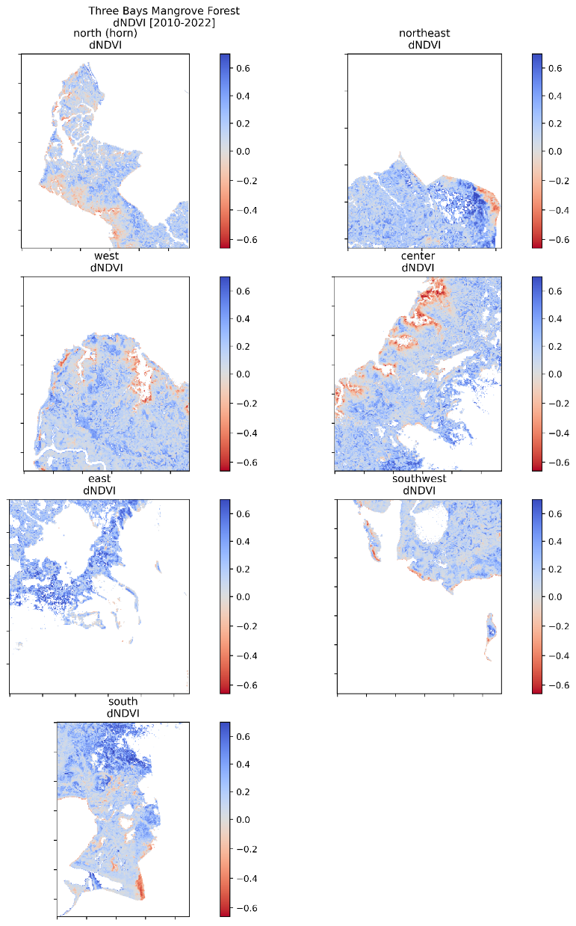

**4.2 Tides Analysis?**

**4.2.1 TPXO stuff?**

**4.3 Mangrove Detection and Cover Change**

*Are the coastline change and apparent extensive inundation and retreat of the salt marsh a result of the mangrove forest cover and density being lowered at a fast pace? With less mangrove being there to slow inundations, more water rushed in overall. On the other side, with more water and stronger currents, ebb flows brought more sediment back to the back of the mangrove forest, leading to healthier and slightly denser mangrove hotspots in that region.*

*If this is true, the following question would be: is sediment from the same sediment discharge from l’Estère, only getting distributed better due to changes in currents, or is it extra-sediments getting mobilized from the marsh being inundated.*

*REPLACE PRELIMINARY SATELLITE IMAGES WITH PLANET RESULTS!!!!*

**Maybe use MTVI2 to track sediment movement.**

**5. Validation and Performance Metrics**

**References**